**Opensearch Dashboard query Perform:-**

GET _cluster/health

* This API endpoint is used to retrieve the health status of the cluster
* **Purpose**: To monitor the overall health of the cluster and its components (nodes, shards, and indices).

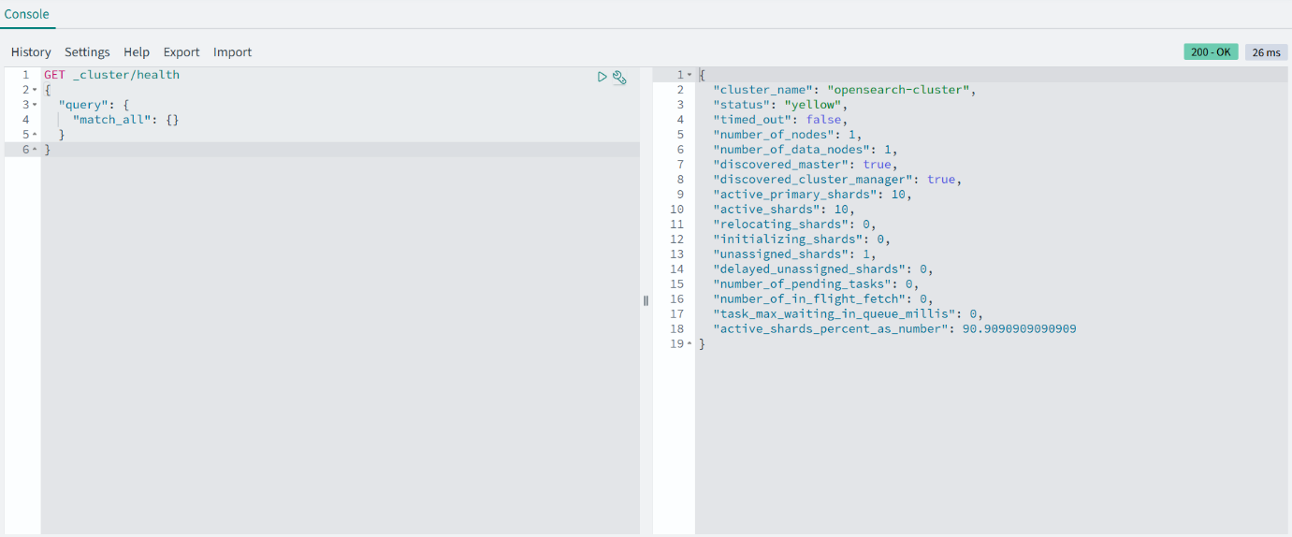

GET _cat/nodes?v

* This is a **Cat API** call used to display information about the nodes in your cluster in a human-readable tabular format.
* The ?v query parameter adds headers to the tabular output

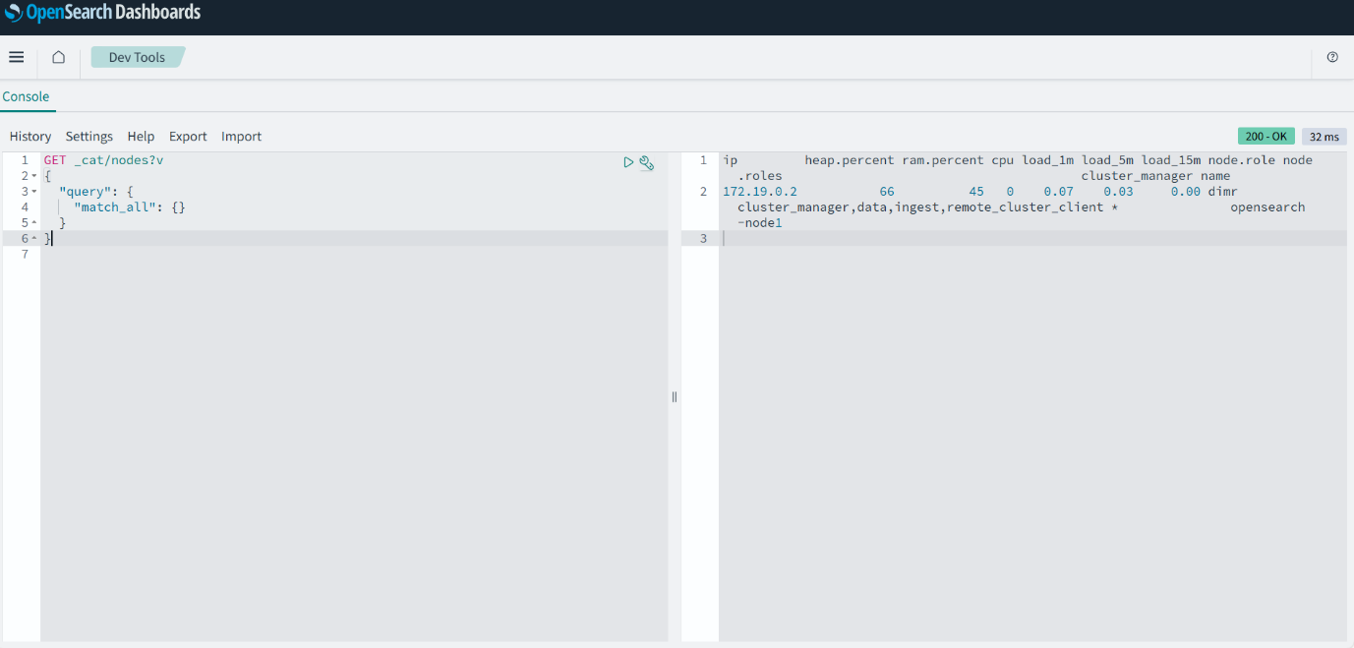

Without using ?v parameter

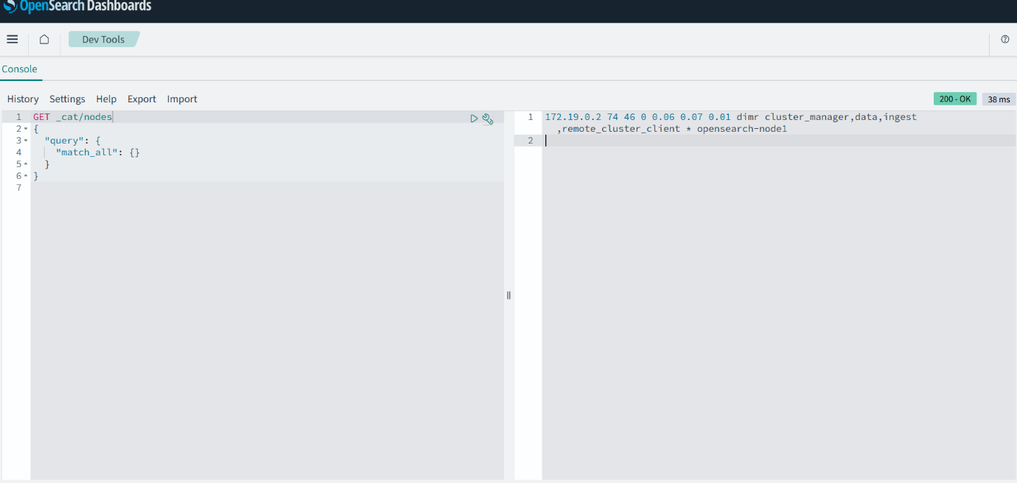

GET _cat/indices?v

* Retrieves information about all indices in the cluster.
* Displays details like the health of each index, its document count, primary and replica shard counts, and more.

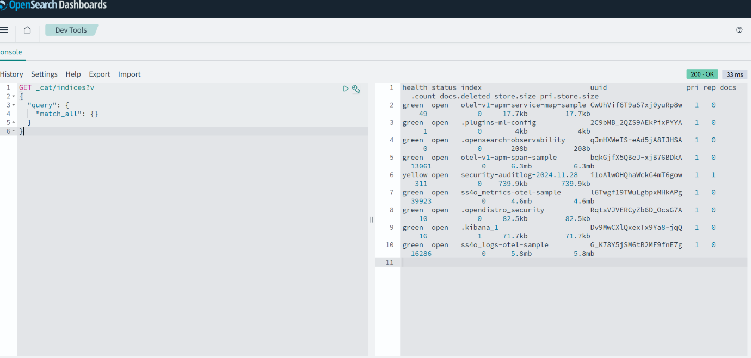

GET _search

* Give all data and all indexes

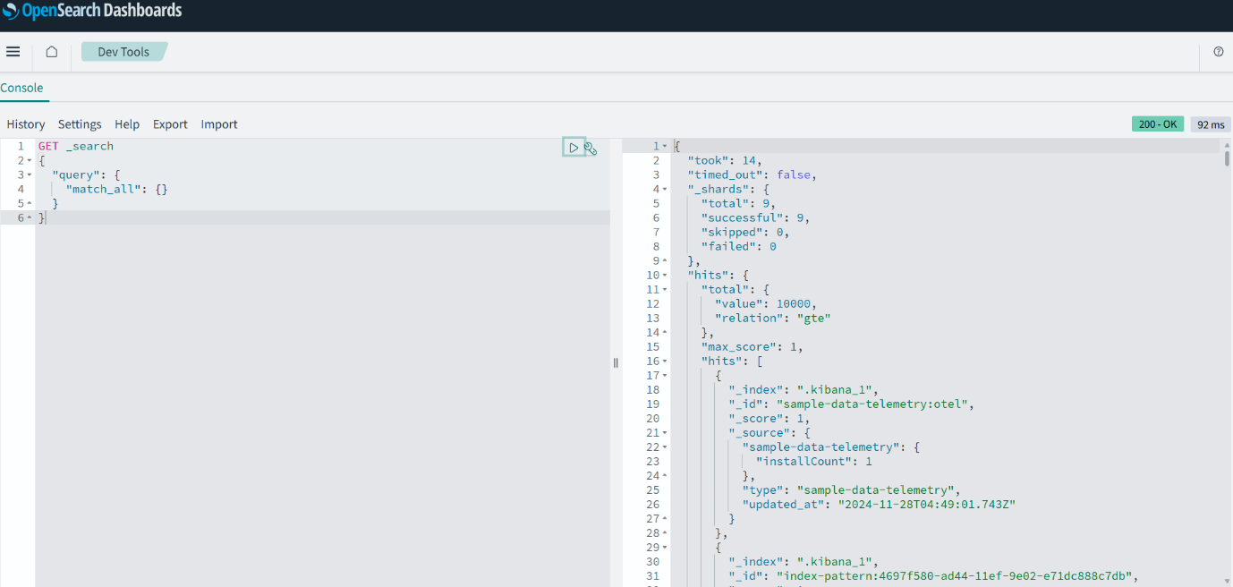

**Shardning :-**

**Create a index**

POST .kibana/_doc/index-pattern-log-pattern

{

"index-pattern": {

"title": "company-*",

"timeFieldName": "@timestamp"

}

}

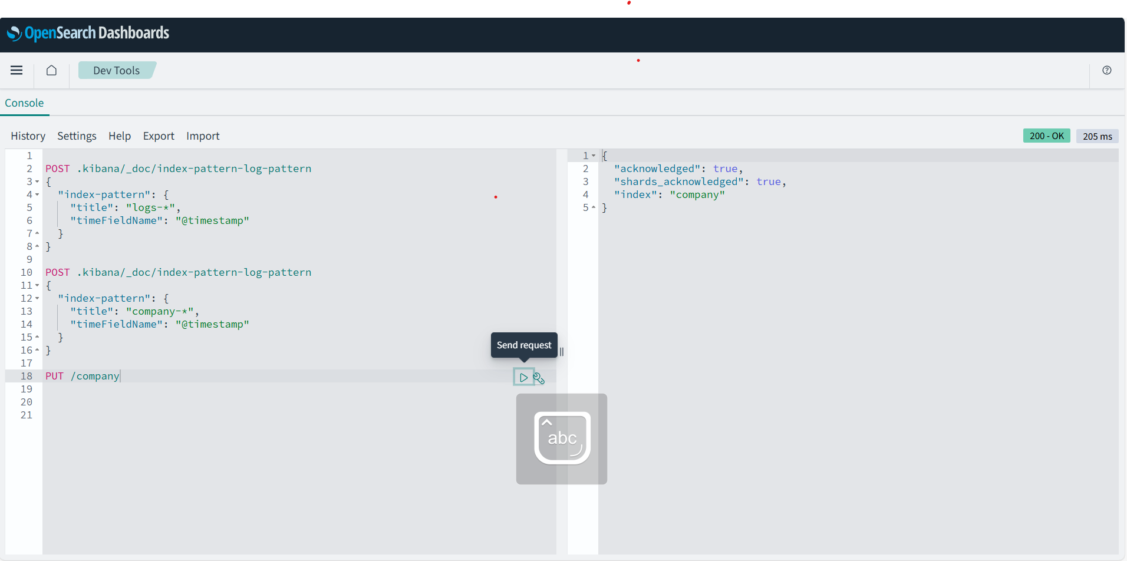

**2. PUT /company**

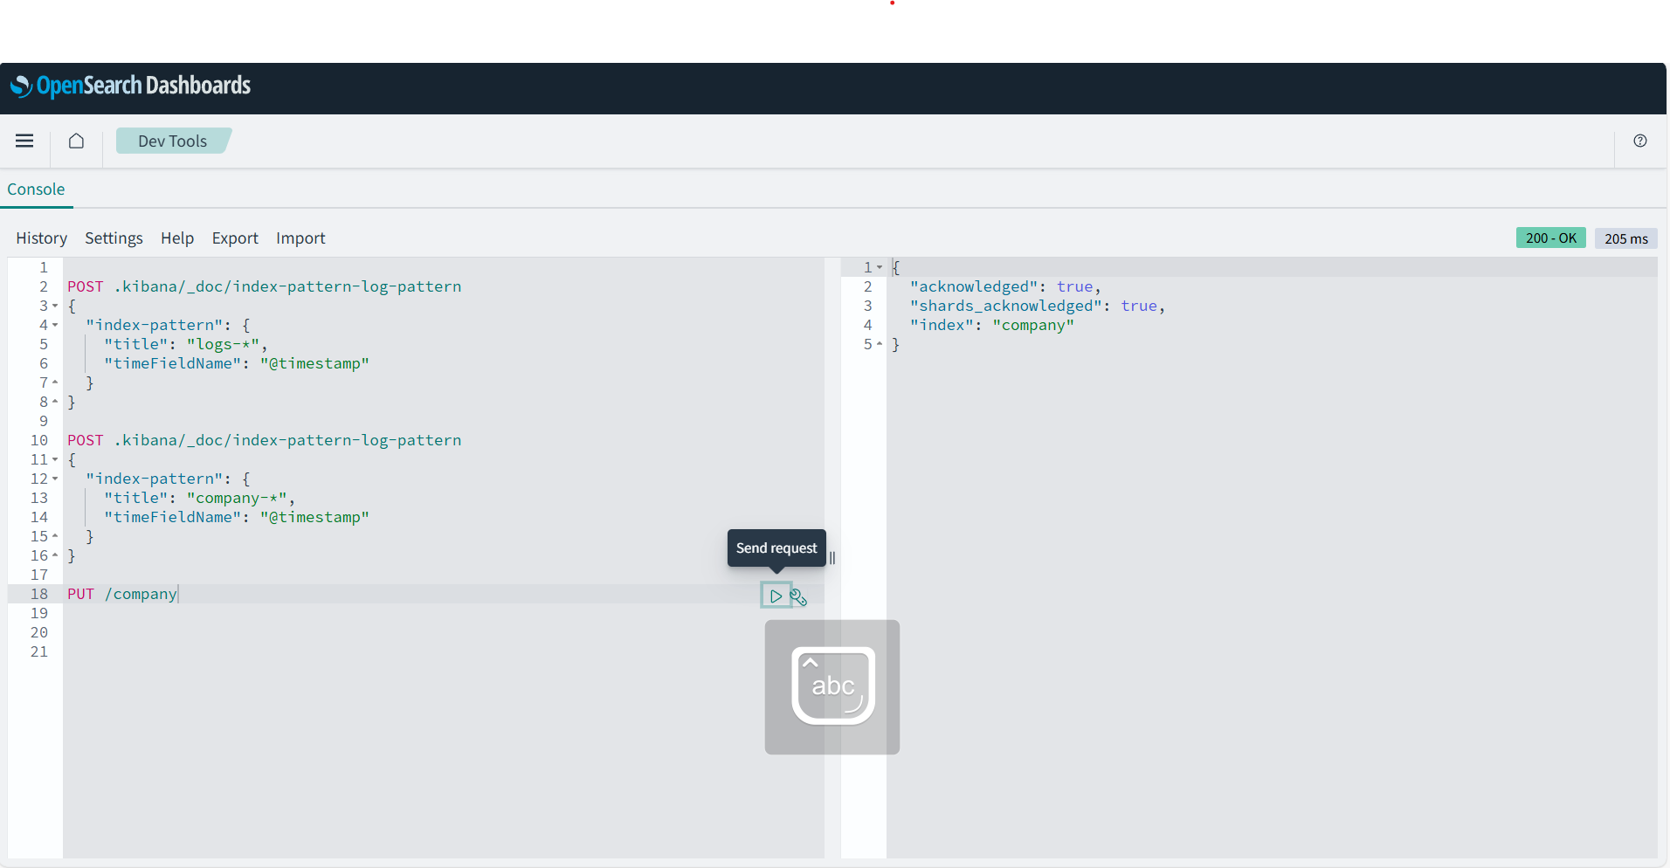

**3. GET _cat/shards?v**

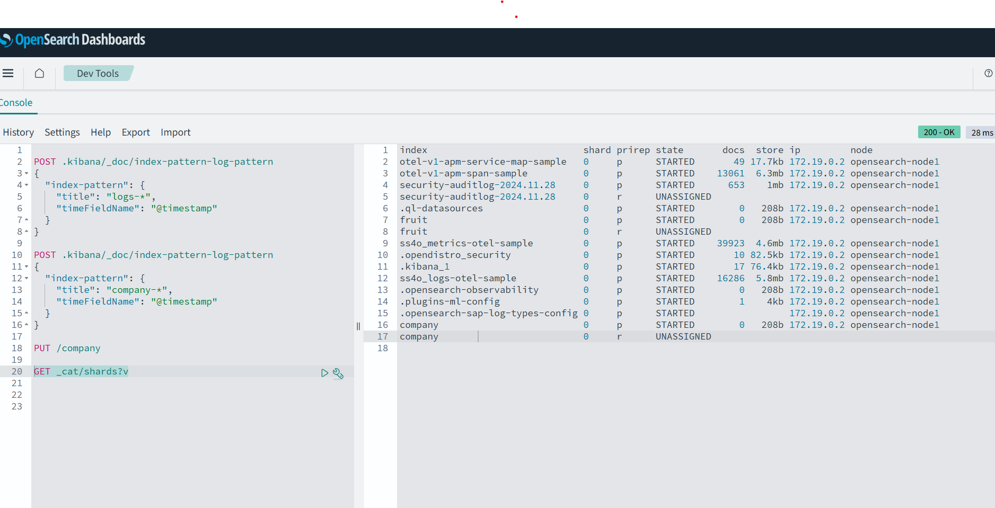

**DELETE company:-**

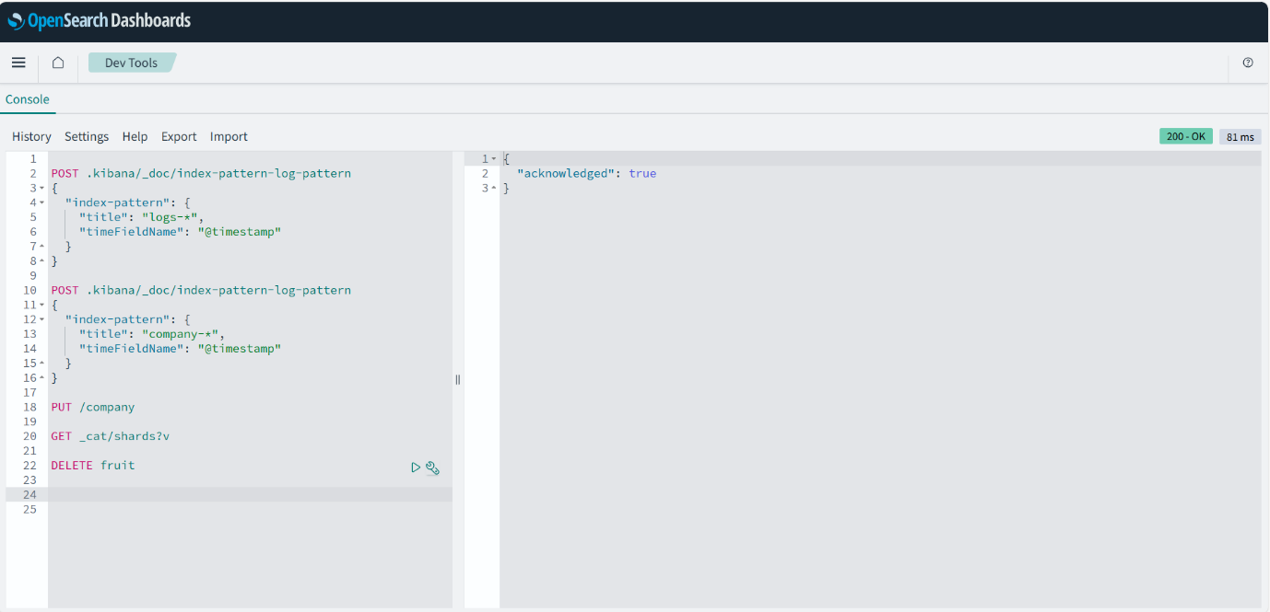

**Recreate index(company) with add extra replica and primary**

**PUT company**

**{**

**"settings": {**

**"number_of_shards": 2,**

**"number_of_replicas": 2**

**}**

**}**

